**Don’t stick me there!**

***Forensics***

**Challenge:**

I woke up after a night out and I'm hurting uh... everywhere... I think I left my phone at one of the bars we were at last night. Thankfully, I was able to see the last photo I took through the cloud.

Can you help me find my phone? I need to know the name of the bar and when the photo was taken.

flagformat: NICC{Bar_Name-HH:MM:SS}

Attached - lastphoto.png

**Approach:**

We extract the metadata of the image, for this purpose we’re going to use the exiftool in linux

Here’s what we got:

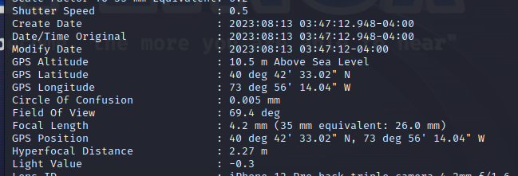

I meant, this is what we’re going to focus on, it gives us the coordinates to a bar named: “The Anchored Inn” and the time of creation is given as “03:47:12”, hence the flag:

**Flag: NICC{The_Anchored_Inn-03:47:12}**

Congrats!!

Happy Hacking!